

**YOGA CENTER**

**Final Release Document**

– HCM, July 19 –

**Table of Contents**

I. Deliverable Package 4

II. Installation Guides 4

III. User Manual 5

1. Overview 5

2. <<Course Enrollment Workflow>> 5

# I. Deliverable Package

| **No.** | **File** | **Notes** |
| --- | --- | --- |
| 1 | YogaCenterDataBB.sql | Database, including both table structures and table data |
| 2 | SWP391-Yoga Center Project_SRS.docx | Final SRS (Requirement) Document |
| 3 | SWP391-Yoga Center Project-SDS.docx | Final SDS (Design) Document |
| 4 | G3-YG_Final Product Backlog.xlsx | Final status for the application functions, which include:  - Function name, feature, roles, function description (changes compared to the original requirements are highlighted)  - In Charge, Planned iteration & Actual iteration  - Final status & note on the update you made  - The links to the SRS & SDS are tracked |
| 5 | Source Code | https://github.com/thanhlong109/webapp-yoga-center-project.git |

Other related deliverables:

* Tagged source codes: https://github.com/thanhlong109/webapp-yoga-center-project.git

# II. Installation Guides

## 1. System Requirement

For Windows 10:

A minimum of 128 MB space on the RAM is mandatory for installing Java into the Windows Operating System.

A minimum of 124 MB space for JRE is necessary. And 2 MB of space on the HDD is mandatory for installing Java into the Windows Operating System.

## 2. Installation Instruction

*✔ Install JDK version 17 by following the instruction at:https://javacodepoint.com/jdk-17-installation-on-windows-10-step-by-step/*

*✔ Download and install MySQLServer 2019*

*<https://www.microsoft.com/en-us/sql-server/sql-server-downloads>*

*✔ Create a database in MySQL by* YogaCenterDataBB.sql

# III. User Manual

[In this part, you provide overall descriptions of the application, the briefs of the application’s workflows and the details guide of each workflow where the end user can use

## 1. Overview

*[Provide the overview of the application and if could, the description of the workflow to help user have the overall information of the application]*

## 2. <<Course Enrollment Workflow>>

**Purpose:** The purpose of this workflow is to guide users through the process of enrolling in a course on the application. Users will learn how to navigate the application, search for courses, view course details, select a course, and complete the enrollment and payment process. The detailed guides provided for each step include clear text instructions to help users understand and use the application effectively.

**Guide:**

**Step 1: Access the Home Page**

* The user opens the application and is directed to the home page.
* Locate the "Login/Register" button at the top right corner of the page.
* Refer to the screenshot below:

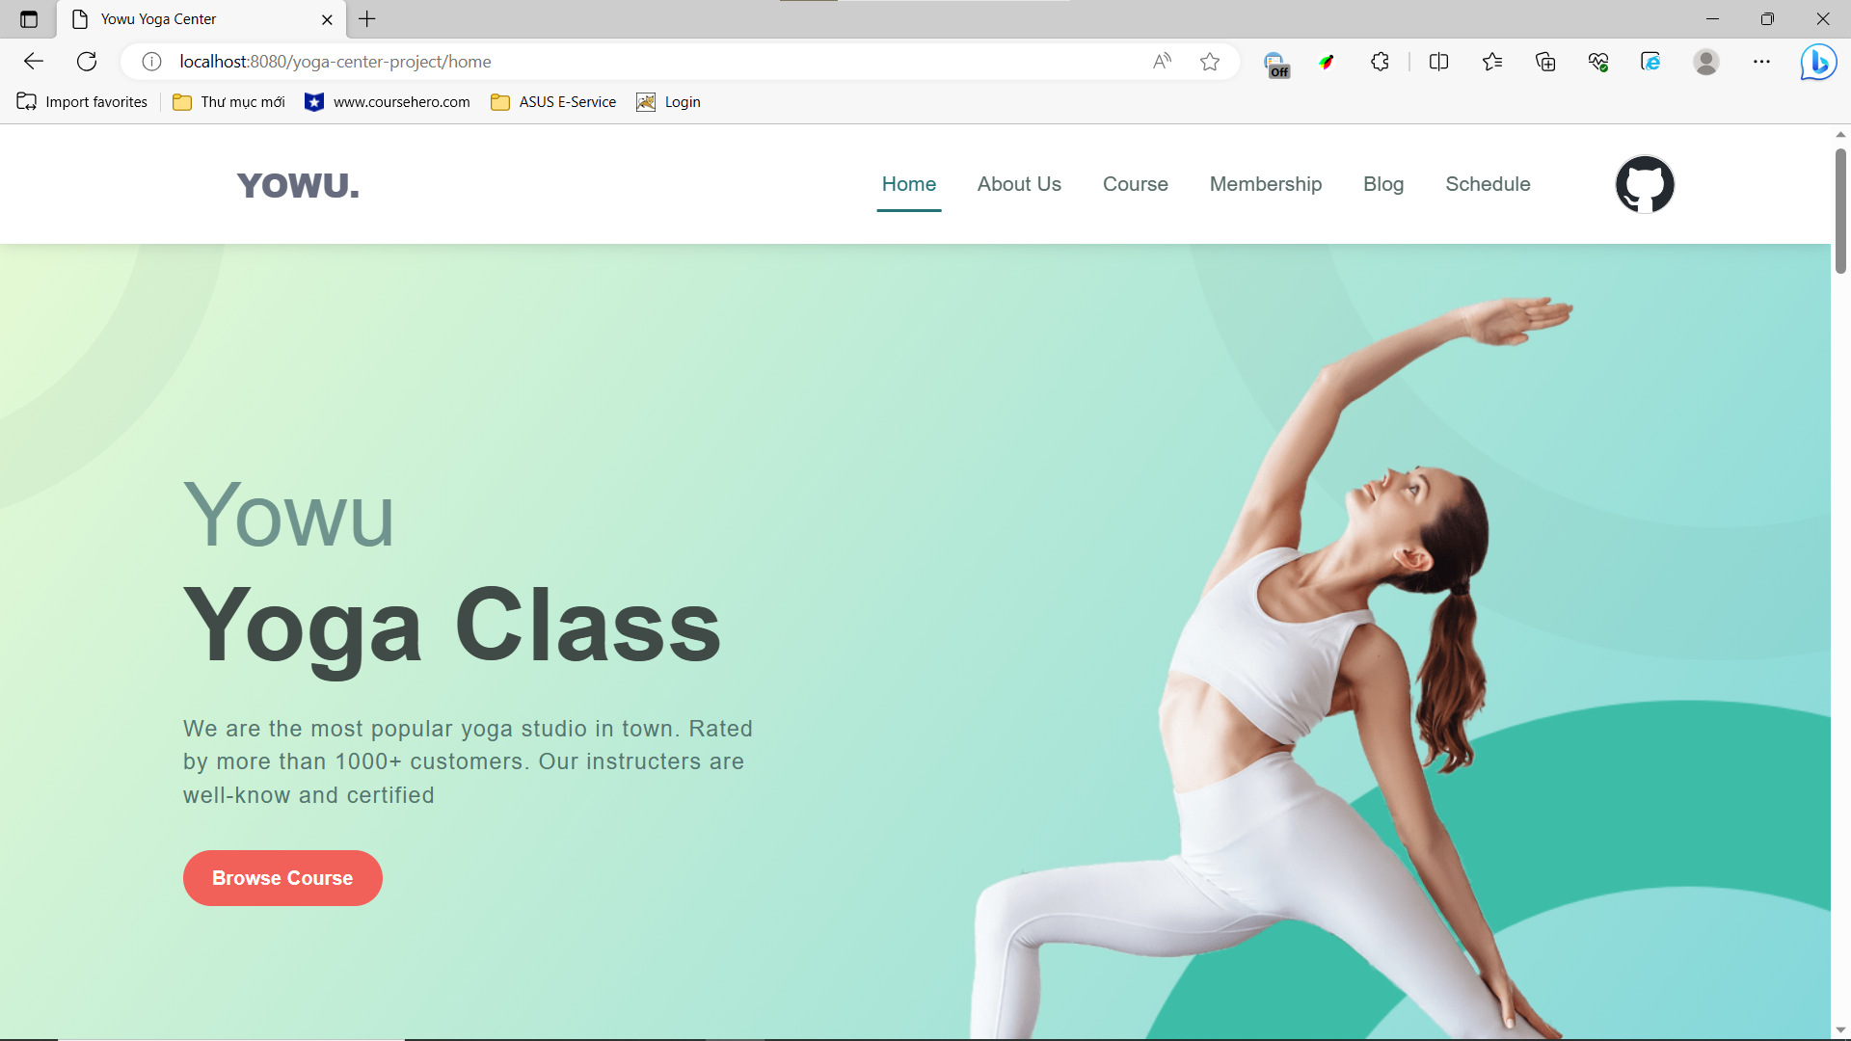

**Step 2: Login or Register**

* Click the "Login/Register" button to proceed.
* If you already have an account, enter your email and password, then click the "Login" button.
* If you don't have an account, you can choose to log in using your Google account or click "Create New Account."
* If selecting "Create New Account," fill in the required registration information (username, email, password), and click the "Signup" button.
* Verify the reCaptcha by ticking the checkbox.
* Refer to the screenshots below:

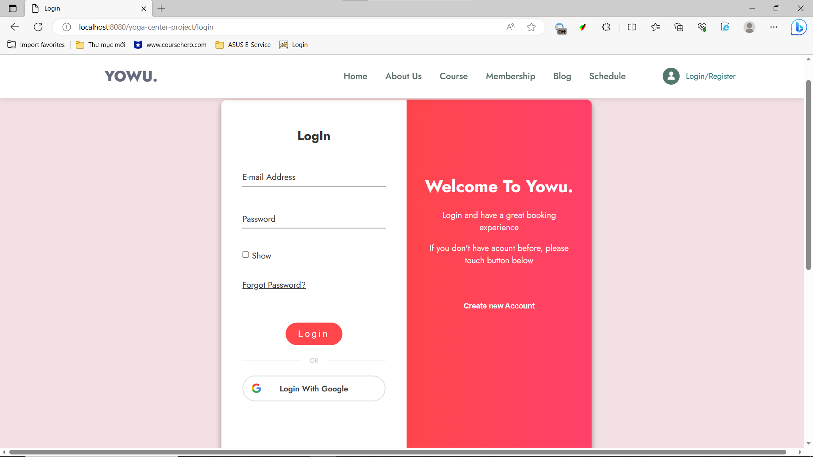

**Step 3: Explore Courses**

* After successfully logging in or registering, you will be redirected to the application's main page.
* Locate the "Course" section on the header and click on it to proceed.
* Filter the course by selecting price, and category and clicking the “Filter” button
* Sort courses by clicking on buttons “Price High - Low”, “Price Low - High”, ”Popular Course”, “Rating Course”
* View teacher infor by clicking on the teacher below each course
* Refer to the screenshot below:

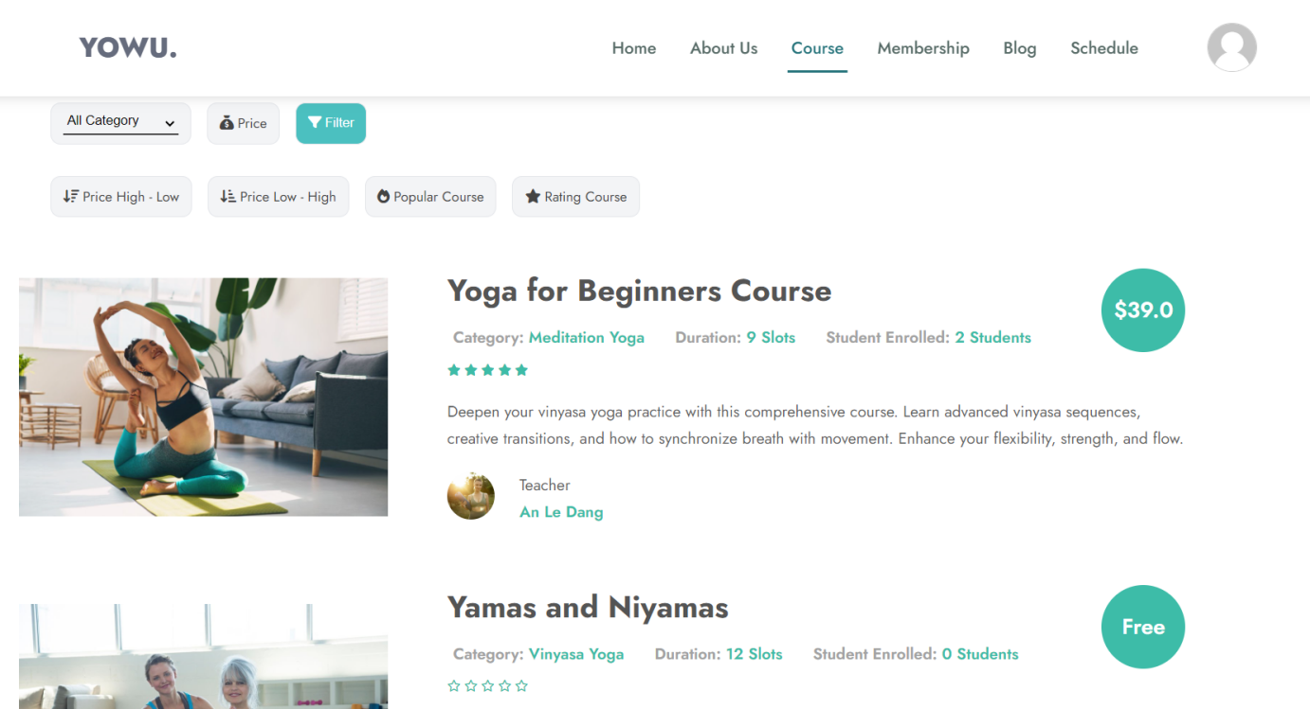

**Step 4: View Course Details**

* Browse through the list of courses and click on a course title to view its details.
* The course details page will display information such as the number of sessions, class schedule, course price, ratings, and feedback.
* Scroll down to see suggested courses.
* Refer to the screenshots below:

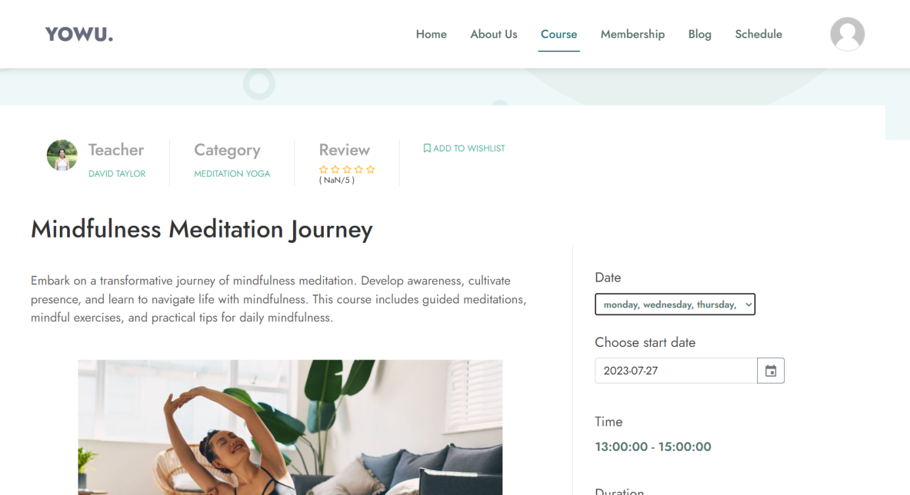

**Step 5: Enroll in a Course**

* On the course details page, click the "date" field to select the days of the week for classes.
* Click the "Choose Start Date" field to select the course starting date.
* After selecting the schedule, click the "Purchase" or "Enroll" button to proceed.
* Refer to the screenshots below:

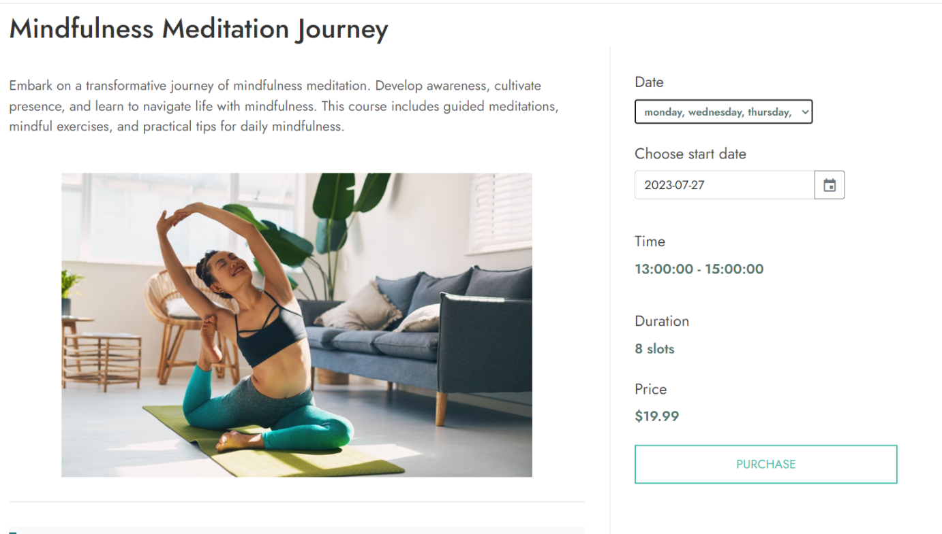

**Step 6: Checkout and Payment**

* After clicking the "Purchase" or "Enroll" button, you will be taken to the Checkout page.
* Review the total price, any applicable discounts, and the enrollment start and end dates.
* Select your preferred payment method: VNPay or Pay at the Counter.
* If choosing VNPay, enter the required payment information and complete the payment within 15 minutes.
* Refer to the screenshots below:

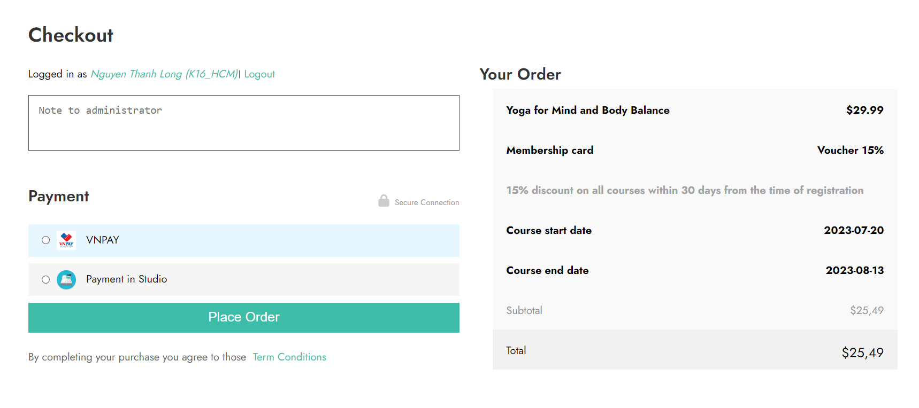

**Step 7: View Schedule**

* Once the payment is successful, access the "Schedule" tab on the header to view your course schedule.
* Select a specific date to see the schedule for that day.
* Refer to the screenshot below:

